Tuition Reimbursement Application Process for Columbus State Certificate Programs

* Go to Inside
* Choose Company > Policies & Guidelines
* Choose Policy Guide
* Scroll down and click: 8 Education & Development Opportunities
* Choose 8.2 Educational Assistance and Opportunities
* Under the first section titled “Educational Assistance Program” click the blue highlighted text “Educational Assistance Application”.
* You may be asked to enter a User ID (your 6-digit associate ID number) and password (if this is your first time logging into this site, the password will be your home zip code). After initial login, you will be asked to create a unique password for future logins.
* This takes you to your personal Edcor Tuition Reimbursement account home page:

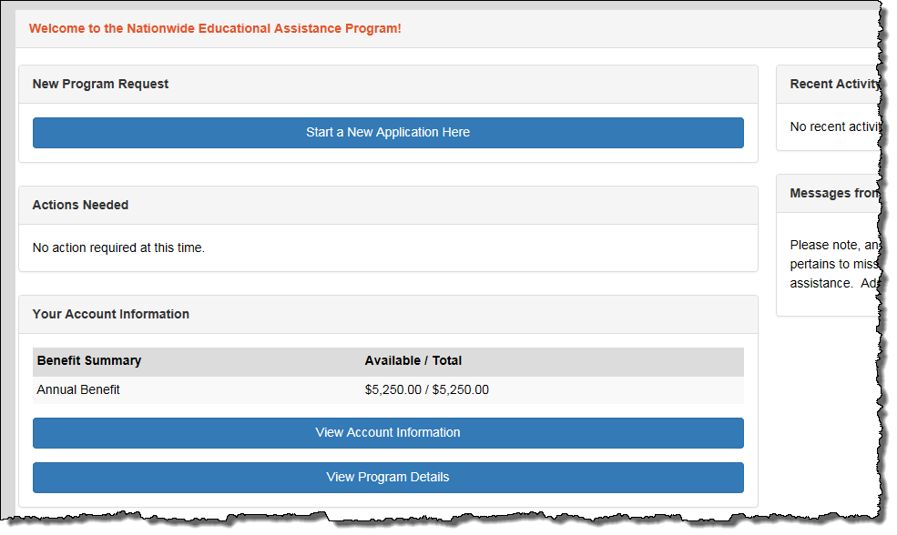

* To request reimbursement, click the blue highlighted bar that says, “Start A New Application Here”.
* You’ll be directed to the New Application – Pre-Screening page. Choose the Undergraduate Studies radio button, scroll down to the bottom and click Proceed.

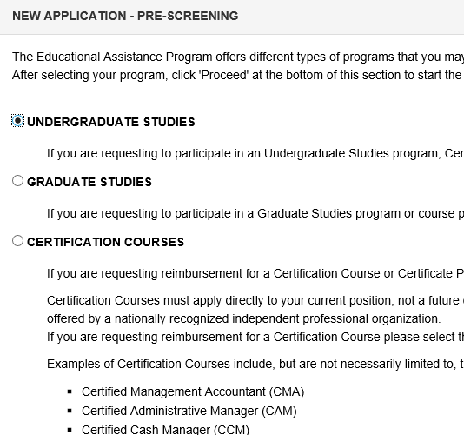

* You’ll be directed to the New Application – checklist page. Please review this checklist to ensure you have all information required to complete the application. Click Proceed.

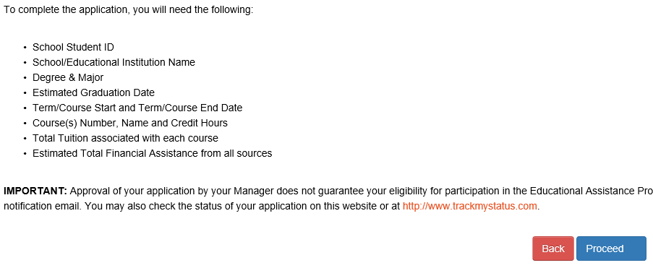

* You’ll then be directed to Payment Type page, choose your preference from the drop-down menu (either “check” or “payroll”) and click Proceed.

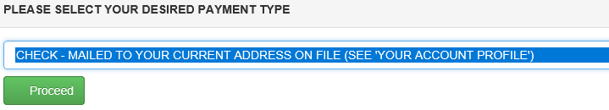

* You will be directed to the New Application page where you will need to populate the following fields:
  + School Student ID
  + School: Columbus State Community College – Main Campus
  + Degree Type: Certificate Degree
  + Major: search for and select CYBERSECURITY, Data Analytics, or Application Development
  + Anticipated Graduation Date: Last day of course/term
  + Course Information: Corresponding course dates and costs. You will need to enter “1” for course credits as this is a required field.

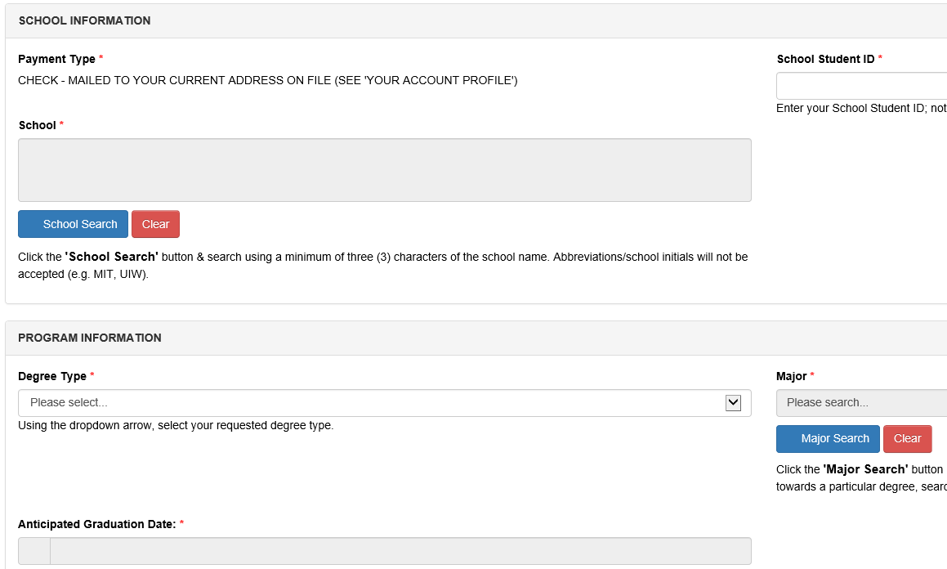

* You will then be directed to the Submit Agreement page. Review the information, scroll down and click I Agree.

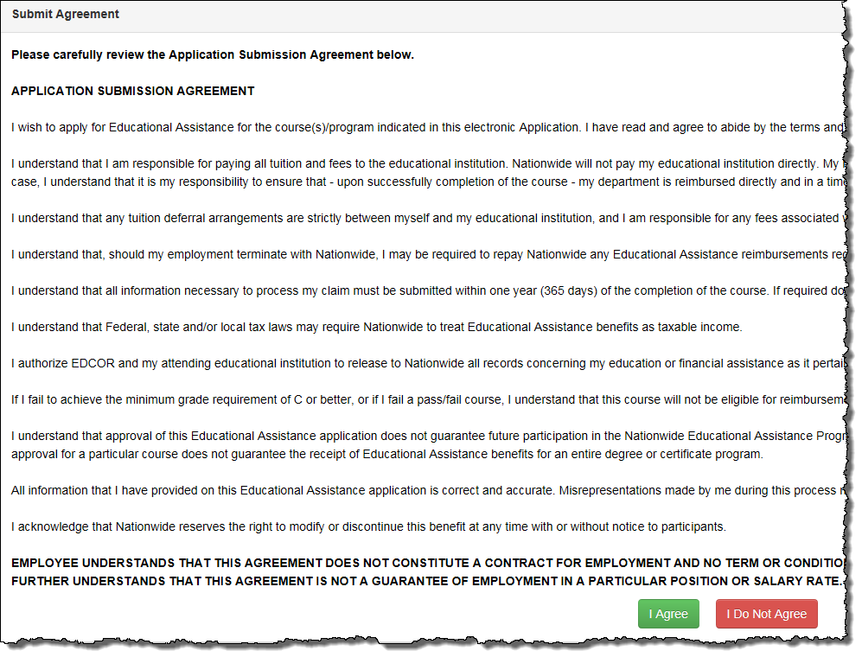

* You’ll then be directed to the New Application Confirmation Page. Click the blue bar reading Submit your Payment and Grade Documentation.

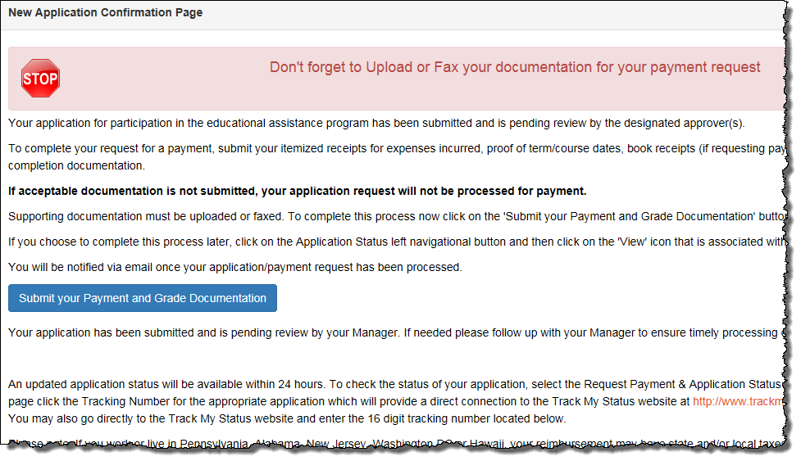

* From there you’re sent to a Submit Your Payment and Grade Information page. This is a mandatory submission you must provide to avoid your reimbursement being rejected.
* Follow the attached instructions to obtain required grade documentation from CSCC



* Upload your documents by clicking the blue bar reading “Upload your Payment and Grade information”

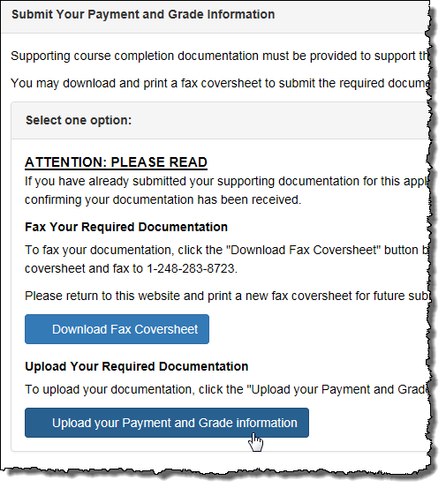

* When uploading your documents, **please pay close attention to the “helpful hints”** and follow the instructions.
* Follow the upload directions, scroll to the bottom of the screen and click Finish. Your manager will then receive an email request to approve the reimbursement. Once the manager approves, it typically takes 2-4 days for Edcor to process and approve payment. From there, the reimbursement will be in your paycheck within 1-2 pay periods, or If you requested reimbursement by check, you should receive a check within 10-12 days.